DAY 1-SQL REFRESHER AND

ADVANCE SQL

**What is SQL?** SQL (Structured Query Language) is the standard language used to interact with relational databases. It is used to perform tasks such as querying data, inserting records, updating records, and managing database structures.

SQL is a [domain-specific language](https://en.wikipedia.org/wiki/Domain-specific_language) used to manage data, especially in a [relational database management system](https://en.wikipedia.org/wiki/Relational_database_management_system) (RDBMS). It is particularly useful in handling [structured data](https://en.wikipedia.org/wiki/Data_model), i.e., data incorporating relations among entities and variables.

Primary key-unique identifier

Domain driven design-we think in terms of domains like (bank system, retail application)  
  
**Types of SQL Commands:**

1. DDL (Data Definition Language) – CREATE, ALTER, DROP
2. DML (Data Manipulation Language) – SELECT, INSERT, UPDATE, DELETE

**How SQL work?**

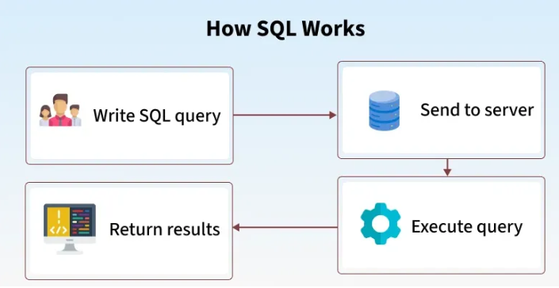

**CREATING THE TABLE:**

Create table students(

Id int primary key,

Name varchar(30),

course varchar(30),

join_date date

);

**INSERTING RECORDS INTO THE TABLE**

Insert into students values

(1,'amit sharma','data engineering','2025-01-09'),

(2,'neha varma','data engineering','2025-01-08'),

(3,'rohit','data engineering','2025-01-10');

**DISPLAY**

Select *from students;

select Name,course from students;

**USING WHERE CLAUSE**

select * from students where course='data engineering';

select * from students where join_date>'2025-01-8';

select * from students where course in ('data engineering','ai');

select * from students where join_date between '2025-01-8' and '2025-01-10';

**PATTERN MATCHING:**

select * from students where Name like 'A%';

select *from students where Name like '%a';

select * from students where Name like '%it%';

**UPDATE:**

update students set course='adv data engineering' where id=1;

update students set join_date='2025-01-18' where Name='rohit';

select * from students;

UPDATE students SET join_date = DATEADD(day, 1, join_date);

**DELETE:**

delete from students where id=1;

delete from students where join_date>'2024-09-19';

**EXERCISE OF DAY-1**

CREATE TABLE departments (

id INT PRIMARY KEY,

dept_name VARCHAR(100));

INSERT INTO departments VALUES

(1, 'Human Resources'),

(2, 'Engineering'),

(3, 'Marketing');

CREATE TABLE employees (

emp_id INT PRIMARY KEY,

emp_name VARCHAR(100),

dept_id INT,

salary INT);

INSERT INTO employees VALUES

(101, 'Amit Sharma', 1, 5),

(102,' Nena Reddy', 2, 45000),

(103,' Faizan Ali', 2, 48800),

(184, 'Divya Mehta', 3, 35000),

(165, 'Ravi Verma', NULL, 28999);

-- employees with dept

select e.emp_name,d.dept_name

from employees e

join departments d

on e.dept_id=d.id;

--

select e.emp_name,d.dept_name

from employees e

left join departments d

on e.dept_id=d.id

where dept_id is null;

--

select d.dept_name,count(e.dept_id) as total

from employees e

join departments d

on e.dept_id=d.id

group by dept_name;

---

select d.id, d.dept_name

from departments d

left join employees e on d.id = e.dept_id

where e.dept_id is null;

--

select e.emp_name,d.dept_name,e.salary

from employees e

join departments d

on e.dept_id=d.id

having e.salary>40000;

**ASSIGNMENT-1**

**--Task1-Create a Table**

create table products(

product_id int primary key,

product_name varchar(30),

category varchar(30),

price decimal(10,2),

stock_quantity int,

added_date date);

**--Task2-Insert Records**

insert into products values

(1,'iphone','electronic',100000.00,5,'2025-03-09'),

(2,'mouse','electronic',1000.00,5,'2025-03-04'),

(3,'saree','fashion',1300.00,8,'2025-01-11'),

(4,'shoes','footwear',3000.00,10,'2025-02-13'),

(5,'laptop','electronic',150000.00,3,'2025-06-08');

**--Task 3: Write Queries**

**--List all products.**

select * from products;

**--Display only product_name and price .**

select product_name,price from products;

**--Find products with stock_quantity less than 10.**

select * from products where stock_quantity<10;

**--Find products with price between 500 and 2000.**

select * from products where price between 500 and 2000;

**--Show products added after 2023-01-01 .**

select * from products where added_date>'2023-01-01';

**--List all products whose names start with ‘S’.**

select * from products where product_name like 'S%';

**--Show all products that belong to either Electronics or Furniture .**

select * from products where category in ('electronic','furniture');

**--Task 4: Update & Delete**

**--Update the price of one product.**

update products set price=1200 where product_id=2;

**--Increase stock of all products in a specific category by 5.**

update products set stock_quantity=(stock_quantity+5) where category='electronic';

**--Delete one product based on its product_id .**

delete from products where product_id=2;

**--Delete all products with stock_quantity = 0**.

delete from products where stock_quantity=0